

IMAGE EDITING



IHENDU IKECHUKWU GODSWILL

**REG. NO: 2023/HND/37593/CS**

**COMPUTER SCIENCE HND 1**

***COURSE CODE: SWD 327***

**IMAGE EDITING**

**IMAGE EDITING** is the process of altering an image using software to improve its appearance, Remove imperfections, or change its composition. It is a common practice in photography, Graphic design, and other creative fields.

Some of the most common image editing techniques include:

● Cropping: Removing unwanted parts of the image.

● Resizing: Changing the size of the image.

● Rotating: Changing the orientation of the image.

● Flipping: Mirroring the image horizontally or vertically.

● Colour correction: Adjusting the colours in the image.

● Contrast enhancement: Increasing or decreasing the contrast between light and dark Areas in the image.

● Sharpening: Making the edges of objects in the image more defined.

● Removing blemishes: Removing imperfections such as red eyes, blemishes, and Wrinkles.

● Adding text: Adding text to the image.

● Adding filters: Applying filters to the image to change its appearance.

● Combining images: Combining multiple images into one.

Image editing can be done using a variety of software programs, such as Adobe Photoshop, GIMP, and Paint.NET. There are also many online image editing tools available.

**Here are some of the benefits of image editing:**

● Improve the appearance of images: Image editing can be used to improve the Appearance of images by removing imperfections, correcting colours, and enhancing Contrast.

● Create new images: Image editing can be used to create new images by combining multiple images or adding text and other elements.

● Tell stories: Image editing can be used to tell stories by adding captions and other text to Images.

● Make images more visually appealing: Image editing can be used to make images more visually appealing by adding filters and other effects. Image editing is a powerful tool that can be used to improve the appearance of images, create new images, and tell stories.

**RETOUCH ACADEMY** is a set of tools and resources designed to help photographers and retouches streamline their workflow in Adobe Photoshop. Here’s a detailed process of editing images using Retouch Academy tools: Step-by-step Guide: Install Retouch Academy Panel: Purchase and download the Retouch Academy Beauty Retouch and Pixel Juggler panels from the Retouching Academy website. Follow the installation instructions provided with the download to install the panels into Adobe Photoshop. Open Your Image in Photoshop: Launch Adobe Photoshop and open the image you want to edit. Set Up Your Workspace: Ensure the Retouch Academy panels are visible. Go to Window > Extensions > Beauty Retouch and Window > Extensions > Pixel Juggler to enable them. Basic Adjustments: Exposure and Colour Correction: Use adjustment layers like Curves, Levels, and Colour Balance to correct exposure and colour tones. The Pixel Juggler panel can help streamline these adjustments. Frequency Separation: Use the Frequency Separation action available in the Beauty Retouch panel: Click the Frequency Separation button. Adjust the Gaussian Blur radius as needed for your image’s resolution. Edit the Low Frequency layer to smooth out skin tones and colours. Edit the High Frequency layer to correct fine details and textures. Dodge and Burn: Create Dodge and Burn layers using the Beauty Retouch panel. Use a soft brush to lighten (dodge) and darken (burn) areas of the image to enhance contours and highlights. This technique helps in shaping the face and giving it a three-dimensional look. Skin Retouching: Use the Skin Retouching tools in the Beauty Retouch panel: Utilize tools like the Healing Brush and Clone Stamp to remove blemishes and imperfections. Use the Skin Smoothing action to achieve a natural, smooth skin texture without losing details. Enhancing Eyes and Lips: Use the Eye and Lips enhancement tools in the Beauty Retouch panel: Brighten and sharpen eyes. Add subtle colour and sharpness to lips to make them pop. Detail Enhancements: Use the Detail Enhancements tools in the Beauty Retouch panel to add extra sharpness and clarity to specific areas like hair, jewellery, and clothing. Final Touches: Use the Vignette and Contrast enhancements available in the Pixel Juggler panel to add final touches and bring focus to the subject. Add any creative effects or final adjustments using additional layers and filters. Save Your Work: Save your edited image in the desired format, such as JPEG or TIFF. Keep a layered PSD file to allow for future adjustments if needed. Tips for Effective Editing with Retouch Academy: Non-Destructive Editing: Always work with duplicate layers and adjustment layers to preserve the original image. Zoom In and Out: Regularly zoom in to work on fine details and zoom out to see the overall effect of your edits. Practice and Experiment: Take time to learn and experiment with different tools and settings in the Retouch Academy panels to understand their impact on your images. Subtlety is Key: Avoid over-editing. Aim for a natural look that enhances the subject without making the edits obvious.

By following these steps and leveraging the powerful tools within the Retouch Academy panels, you can achieve professional-level retouching results with efficiency and precision.

**UNEDITED PICTURE**

An unedited picture captures the scene exactly as it was at the moment it was taken, preserving all the natural elements, colours, and details without any alterations. It serves as an authentic representation of reality, showcasing the true light, shadows, and textures. Unedited images often reveal the photographer’s skill in framing, composition, and timing, highlighting the raw beauty or imperfections of the subject. While editing can enhance or stylize an image, an unedited picture maintains its originality, offering a genuine and often more powerful connection to the moment it depicts.

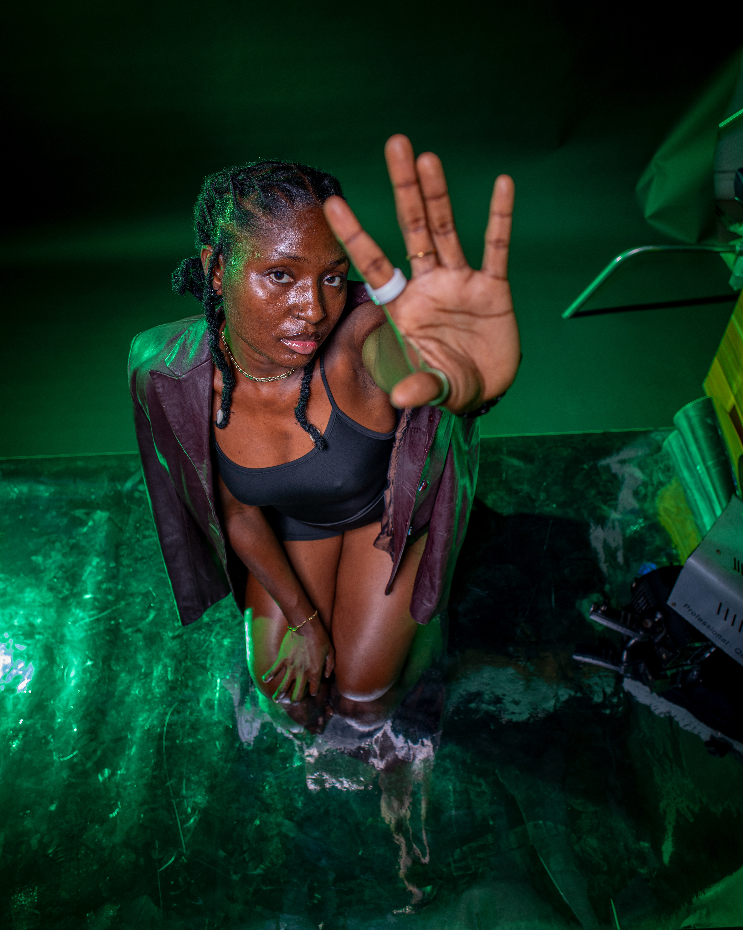

**BEFORE EDITING**

**EDITED PICTURE STEPS**

When a picture is edited, several processes might be applied to enhance, correct, or creatively alter the image. These processes can include:

* ***Colour Correction:*** Adjusting the brightness, contrast, saturation, and white balance to make the colours more accurate or visually appealing.
* ***Cropping:*** Trimming parts of the image to improve composition, remove distractions, or focus more closely on the subject.
* ***Retouching:*** Smoothing skin, removing blemishes, or correcting other imperfections in the image, such as dust spots or lens flare.
* ***Sharpening:*** Enhancing the clarity of the image by improving the edge definition, making details appear crisper.
* ***Noise Reduction:*** Reducing the graininess or visual noise, especially in low-light photographs, to create a cleaner image.
* ***Background Removal or Replacement:*** Changing or removing the background to isolate the subject or place it in a different context.
* ***Filters and Effects:*** Applying stylistic filters or special effects to create a particular mood or aesthetic, such as vintage looks, black and white, or HDR (High Dynamic Range).
* ***Resizing and scaling:*** Changing the dimensions of the image to fit specific formats or resolutions, often for print or online use.
* ***Text and Graphics Overlay:*** Adding text, logos, or other graphical elements to the image for branding, messaging, or design purposes.

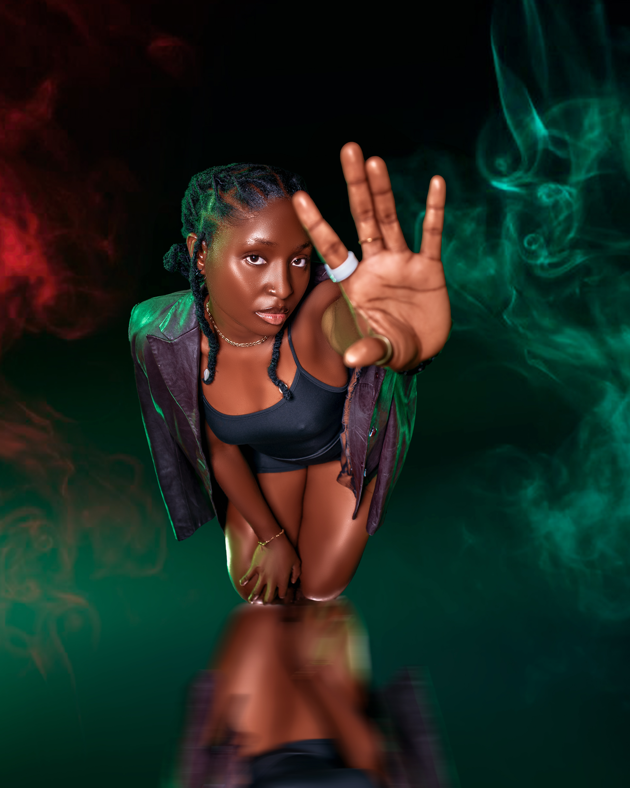

**EDITED PICTURE**





**CERTIFICATE OF IMAGE EDITING OBTAINED**

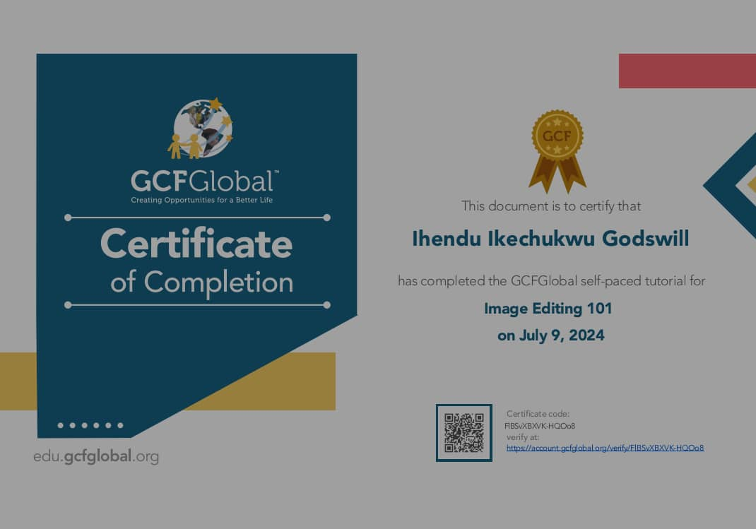

***AFTER***

***BEFORE***